**What Is a T-Test?**

A t-test is an inferential [statistic](https://www.investopedia.com/terms/s/statistics.asp) used to determine if there is a significant difference between the means of two groups and how they are related.

The t-test is just one of many tests used for Hypothesis Testing. Statisticians use additional tests other than the t-test to examine more variables and larger sample sizes.

**For a large sample size**, statisticians use a [z-test](https://www.investopedia.com/terms/z/z-test.asp) (where, z-statistic follows a normal distribution ), while **for a smaller sample size,** t-test is preferred. Other testing options include the chi-square test and the f-test.

### **KEY TAKEAWAYS**

* A t-test is an inferential statistic used to determine if there is a statistically significant difference between the means of two variables.
* The t-test is a test used for hypothesis testing in statistics.
* Calculating a t-test requires three fundamental data values including the difference between the mean values from each data set, the standard deviation of each group, and the number of data values.

## Understanding the T-Test

A t-test compares the average values of two data sets and determines if they came from the same population. For example, samples taken from the placebo-fed control group and those taken from the drug prescribed group should have a different mean and standard deviation.

Mathematically, the t-test takes a sample from each of the two sets and establishes the problem statement. **It assumes a null hypothesis that the two means are equal.**

Thus, Ho : The two samples have same mean.

Using the formulas, values are calculated and compared against the standard values. The assumed null hypothesis is accepted or rejected accordingly. If the null hypothesis qualifies to be rejected, it indicates that data readings are strong and are probably not due to chance.

**T-test formula and example:**

Say after the drug trial, the members of the placebo-fed control group reported an increase in average life expectancy of three years, while the members of the group who are prescribed the new drug reported an increase in average life expectancy of four years.

Initial observation indicates that the drug is working. However, we should rush to any conclusion because it is also possible that the observation may be due to chance. A t-test can be used to determine if the results are correct and applicable to the entire population.

The t-test produces two values as its output: t-value and [degrees of freedom](https://www.investopedia.com/terms/d/degrees-of-freedom.asp). The t-value, or t-score, is a ratio of the difference between the mean of the two sample sets and the variation that exists within the sample sets.

This calculated t-value is then compared against a value obtained from a critical value table called the T-distribution table. Higher values of the t-score indicate that a large difference exists between the two sample sets. The smaller the t-value, the more similarity exists between the two sample sets. **When the null is true (i.e. two sets are similar), your study is most likely to obtain a t-value near zero (at center) and less liable to produce t-values further from zero in either direction.**

**Use the t-Distribution to Compare Your Sample Results to the Null Hypothesis**

To evaluate how compatible your sample data are with the null hypothesis, place your study’s t-value in the t-distribution and determine how unusual it is.

The sampling distribution below displays a t-distribution with 20 degrees of freedom, which equates to a sample size of 21 for a 1-sample t-test. When the null is true, your study is most likely to obtain a t-value near zero and less liable to produce t-values further from zero in either direction.

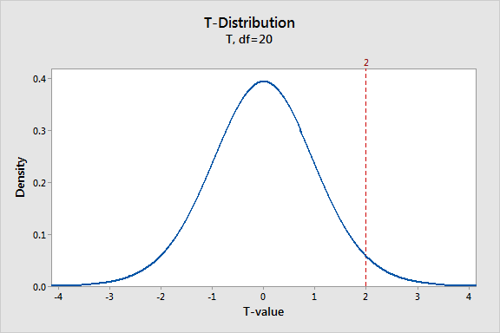

We know that our t-value of 2 is rare when the null hypothesis is true. How rare is it exactly? Our final goal is to evaluate whether our sample t-value is so rare that it justifies rejecting the null hypothesis for the entire population based on our sample data. To proceed, we need to quantify the probability of observing our t-value.

As discussed before,

1. If the t-value is farther away from 0 value, the more likely we are to reject the Null Hypothesis Ho because higher t-value implies higher is the difference b/w the means of the two data set.
2. If t-value = 0 or nearer to 0, then we say that there is good chance that the two data set have same (or close ) value for means . Therefore we are less likely to reject the Ho.

If a t-value(here t-value = +2 ) is sufficiently improbable when assuming that the null hypothesis is true, you can reject the null hypothesis. BUT, how do we decide if they are sufficiently away or Not??????

ANSWER: **p-value test** .

Consider these points(t-value of +2 and -2) for a two-tailed Hypothesis Testing, the graph below finds the probability associated with t-values less than -2 and greater than +2 using the area under the curve.

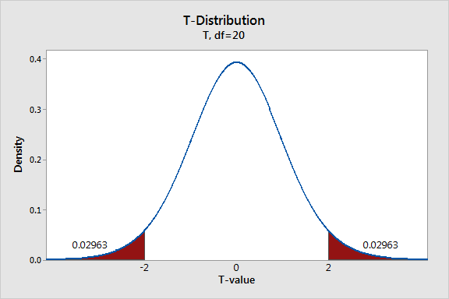

The probability distribution plot indicates that each of the two shaded regions has a probability of 0.02963—for **a total of 0.05926**. This graph shows that t-values fall within these areas almost 6% of the time when the null hypothesis is true.

There is a chance that you’ve heard of this type of probability before—**it’s the P value** (= 6% = 0.05926) .While the likelihood of t-values falling within these regions seems small, it’s not quite unlikely enough to justify rejecting the null under the standard [significance level](https://statisticsbyjim.com/glossary/significance-level/) of 0.05.

Or, in other words, since **p-value> 0.05 🡪 we cannot reject the Null Hypothesis** i.e. we cannot say that for sure the two means are different i.e **there is sufficient evidence ( = probability of 6%) that the two samples have different means.**